# Flow Documentation - 0504_Parent_Approves_Membership-0E8B2B6F-4DF3-EE11-A1FD-000D3A65976C

|  |  |
| --- | --- |
| **Flow Name** | 0504_Parent_Approves_Membership-0E8B2B6F-4DF3-EE11-A1FD-000D3A65976C |
| **Documentation generated at** | Wednesday, April 17, 2024 2:58 PM |
| **Number of Variables** | 0 |
| **Number of Actions** | 3 |

## Flow Overview

The following chart shows the top level layout of the Flow. For a detailed view, please visit the section called Detailed Flow Diagram

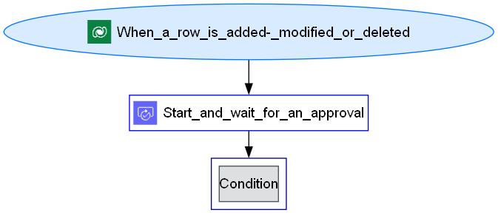

## Connections

There are a total of 2 connections used in this Flow:

### shared

|  |  |
| --- | --- |
| **Connector** | [shared](https://docs.microsoft.com/connectors/shared) |
| **Connection Type** | ConnectorReference |
| **Connection Reference Name** | new_sharedcommondataserviceforapps_52ba3 |
| **Source** | embedded |

## Variables

## Trigger

|  |  |
| --- | --- |
| **Name** | When_a_row_is_added,_modified_or_deleted |
| **Type** | OpenApiConnectionWebhook |
| **Connector** | commondataserviceforapps |
| **Inputs Details** | |
| **parameters** | |  |  | | --- | --- | | subscriptionRequest/message | 1 | | subscriptionRequest/entityname | crfed_cadastro | | subscriptionRequest/scope | 4 | |
| **host** | |  |  | | --- | --- | | apiId | /providers/Microsoft.PowerApps/apis/shared_commondataserviceforapps | | connectionName | shared_commondataserviceforapps | | operationId | SubscribeWebhookTrigger | |
| **authentication** | @parameters('$authentication') |

## Actions

There are a total of 3 actions used in this Flow:

### Condition

|  |  |
| --- | --- |
| **Name** | Condition |
| **Type** | If |
| **Expression** | |  |  |  |  | | --- | --- | --- | --- | | and | |  |  | | --- | --- | | startsWith | @body('Start_and_wait_for_an_approval')?['outcome']  A | | |
| **Elseactions** | Delete_a_row |

### Delete_a_row

|  |  |
| --- | --- |
| **Name** | Delete_a_row |
| **Type** | OpenApiConnection |
| **Connection** | |  |  | | --- | --- | |  | [Microsoft Dataverse](https://docs.microsoft.com/connectors/commondataserviceforapps) | |
| **Inputs** | |
| **parameters** | |  |  | | --- | --- | | entityName | crfed_cadastros | | recordId | @triggerBody()?['crfed_cadastroid'] | |
| **host** | |  |  | | --- | --- | | apiId | /providers/Microsoft.PowerApps/apis/shared_commondataserviceforapps | | connectionName | shared_commondataserviceforapps | | operationId | DeleteRecord | |
| **authentication** | @parameters('$authentication') |

### Start_and_wait_for_an_approval

|  |  |
| --- | --- |
| **Name** | Start_and_wait_for_an_approval |
| **Type** | OpenApiConnectionWebhook |
| **Connection** | |  |  | | --- | --- | |  | [Approvals](https://docs.microsoft.com/connectors/approvals) | |
| **Inputs** | |
| **parameters** | |  |  | | --- | --- | | approvalType | BasicAwaitAll | | WebhookApprovalCreationInput/title | Attempt at Gym Registration | | WebhookApprovalCreationInput/assignedTo | @triggerBody()?['new_parentemail'] | | WebhookApprovalCreationInput/details | Your child is attempting enter a campaign from our gym, Power Gym Girls. Do you approve? | | WebhookApprovalCreationInput/enableNotifications | True | | WebhookApprovalCreationInput/enableReassignment | True | |
| **host** | |  |  | | --- | --- | | apiId | /providers/Microsoft.PowerApps/apis/shared_approvals | | connectionName | shared_approvals | | operationId | StartAndWaitForAnApproval | |
| **authentication** | @parameters('$authentication') |
| **Next Action(s) Conditions** | Condition [Succeeded] |

## Detailed Flow Diagram

The following chart shows the detailed layout of the Flow

